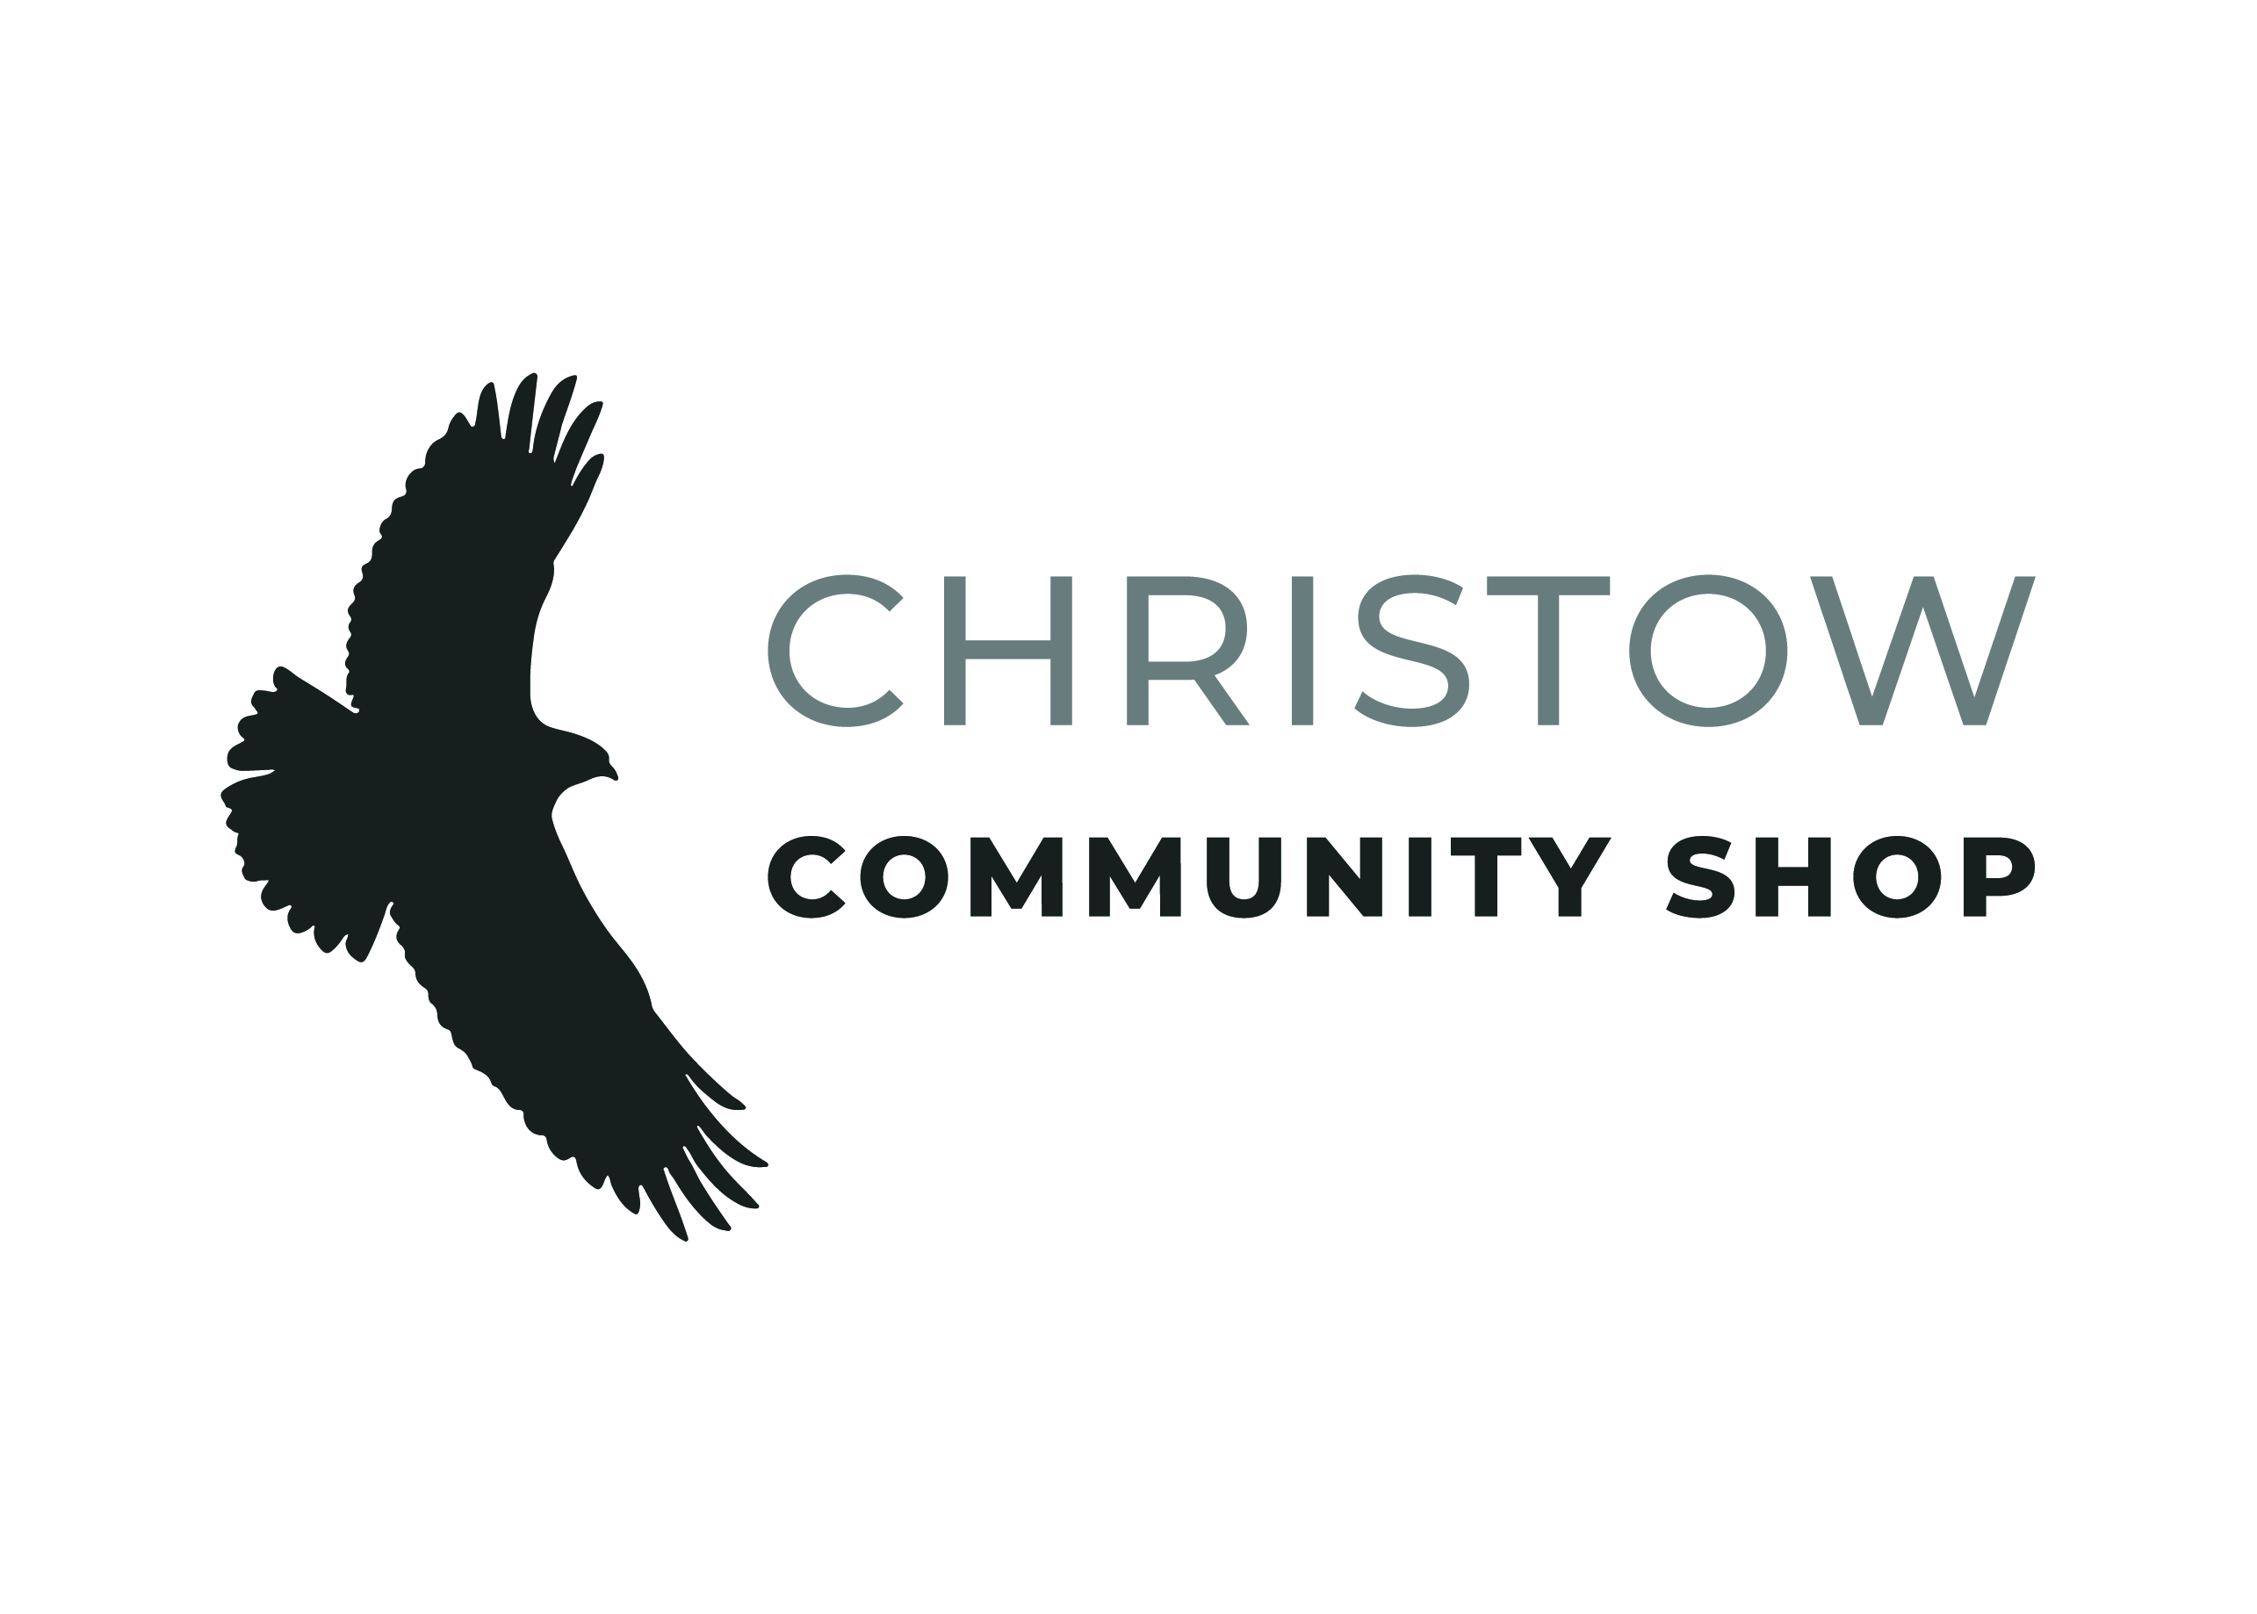

|  |
| --- |
| Role: **Shop Volunteer** |

**PERSONAL DETAILS**

|  |  |  |
| --- | --- | --- |
| Title: | First name: | |
| Last name: | | |
| Address: | | |
|  | | Postcode: |
| Home phone: | | |
| Mobile: | | |
| Email: | | |
| Date of birth*: | | |

*It’s useful to know your date of birth as we want to make sure all ages have a chance to get involved with us. We don’t use this info to decide whether you can volunteer or not. If you are under 18 please **always** state your date of birth, as additional checks are required.

**EMERGENCY CONTACT**

|  |
| --- |
| Name: |
| Relationship to you: |
| Phone: |

**AVAILABILITY**

Please check/click all that apply:

Which days are you available to volunteer? ☐ Mon ☐ Tue ☐ Wed ☐ Thu ☐ Fri ☐ Sat ☐ Sun

At which times? ☐ Morning ☐ Afternoon ☐ Evening

|  |
| --- |
| Other: |

**REFERENCE**

Please give details for one referee that you are happy for us to contact. They must have known you for at least 2 years and not be a relative, in a personal relationship with you or live at the same address. They do not have to be a past employer. Please always provide their email address whenever possible.

|  |
| --- |
| Name: |
| Email: |
| Phone (only if no email): |

**BACKGROUND**

Please tell us a little bit about yourself including any skills or life experience that you would like to bring to this volunteering role. Please include any relevant work experience or employers – thank you.

|  |
| --- |
|  |

**HOW DID YOU HEAR ABOUT VOLUNTEERING WITH US?**

Please check/click all that apply:

☐ Personal connection with shop team ☐ Word of mouth ☐ Social media ☐ Our website

☐ Local shop ☐ An event ☐ Local press

|  |
| --- |
| Other: |

**HEALTH DECLARATION**

Please be aware that any disclosures here are strictly confidential and considered in line with the Disability Discrimination Act 2010. Do you have any health issues, disabilities or additional support or access needs that will require us to make adaptations for the volunteer application process, or in your volunteering role? If yes, please provide details:

|  |
| --- |
|  |

**YOUR INFORMATION**

Under the provisions of UK Data Protection regulations all personal details supplied on this form will be treated as confidential and will only be used for the recruitment and ongoing management of volunteers. During your voluntary position we may be required to process information relating to your health where it is necessary for us to ensure your safety and wellbeing in carrying out your role. All personal information will be kept securely with access limited to those who need to see it to carry out their role. It is important that you advise us of any changes to your personal details so that our records remain current.

**DISCLOSURE OF CRIMINAL RECORD (please complete this section if you are 16 or over)**

**Christow Community Shop policy statement on recruiting volunteers with a criminal record**

Christow Community Shop recognises the contribution that ex-offenders can make. A person’s criminal record will not de-bar that person from volunteering with us. Suitable applicants will not be refused a role because of the offence/s, which are not relevant to and **do not place them at or make them a risk in** the intended volunteering role.

Each disclosure is reviewed on an individual basis and will take the following into account:

* Whether the conviction is relevant to the role
* The seriousness of any offence/s revealed
* The age of the applicant at the time of the offence/s
* The length of time since the offence/s occurred
* Whether the volunteer has a pattern of offending behaviour
* Circumstances surrounding the offence/s and the explanation/s offered by applicant
* Whether the applicant’s circumstances have changed since the offending behaviour

All applicants: Do you have any unspent convictions? ☐ Yes ☐ No

Do you have any spent convictions? ☐ Yes ☐ No

If yes to either question, please provide details of your criminal record here.:

|  |
| --- |
|  |

**DECLARATIONS**

I understand that Christow Community Shop welcomes young and vulnerable adult volunteers, and that it has systems in place to promote safeguarding for children and vulnerable adults to which I will adhere.

I understand that declaration of a criminal record will not necessarily prevent me from volunteering at Christow Community Shop.

I declare that all the information I have given on this form is correct and complete.

|  |  |
| --- | --- |
| Signed (or print name if completing form online): | Date: |

Thank you for completing this application. Please return the form to Jude Jones, Court Dale, Village Road, Christow, EX6 7NF or email a scanned copy to [volunteers@christowshop.org.uk](mailto:volunteers@christowshop.org.uk)

The information disclosed on this form will be kept securely, used as part of the volunteer recruitment process then kept on file for the duration of your time as a volunteer. Thereafter it will be destroyed.

Christow Community Shop is committed to equal opportunities in all our activities. The information on this form is important to help ensure we can monitor applicants for equality purposes and will be treated in confidence. This section is optional but very helpful to us – thank you. If you are doing this online you can just click a box to check it.

|  |  |  |
| --- | --- | --- |
| **GENDER** | | |
| **☐** Male | ☐ Female | ☐ Other |

|  |  |  |  |  |  |  |
| --- | --- | --- | --- | --- | --- | --- |
| **AGE** | | | | | | |
| ☐ Under 18 | ☐ 18 – 25 | ☐ 26 – 35 | ☐ 36 – 45 | ☐ 46 – 55 | ☐ 56 – 65 | ☐ 66+ |

|  |  |  |
| --- | --- | --- |
| **DISABILITY** | | |
| Do you consider yourself to have a disability? | ☐ Yes | ☐ No |

|  |  |  |  |  |  |
| --- | --- | --- | --- | --- | --- |
| **ETHNICITY** | | | | | |
| **White** | | | | | |
| ☐ White British | | | ☐ White Irish | | |
| ☐ Other White background - please specify: | | | | | |
| **Mixed** | | | | | |
| ☐ White and Asian | | ☐ White and Black African | | | ☐ White and Caribbean |
| ☐ Other Mixed background - please specify: | | | | | |
| **Black** | | | | | |
| ☐ African | | | ☐ Caribbean | | |
| ☐ Other Black background - please specify: | | | | | |
| **Asian** | | | | | |
| ☐ Bangladeshi | ☐ Indian | | | ☐ Pakistani | |
| ☐ Other Asian background - please specify: | | | | | |
| **Other Ethnic Group** | | | | | |
| ☐ Chinese | ☐ Latino | | | ☐ Arab | |
| ☐ Prefer not to say | | | | | |